**Week-2**

**------------------------------------------------------------------------------------------------------------**

**AIM:** Design of the cart page and the registration page required for online book store.

1. **CART PAGE DESCRIPTION:**

The cart page contains the details about the books which are added to the cart.

**PROGRAM:**

<html>

<body>

<center><br><br><br>

<imgsrc=”E:\aa.jpg”>

<table border=1 cellpadding=center>

<thead>

<tr>

<th>Book name</th>

<th>price</th>

<th>quantity</th>

<th>amount</th>

</tr>

</thead>

<tr>

<td>java 2</td>

<td>$45</td>

<td>2</td>

<td>$70</td>

</tr>

<tr>

<td> XML bible</td>

<td> $20</td>

<td> 5</td>

<td> $40</td>

</tr>

<thcolspan=4>total amount=$110>

</th>

</tr>

</table>

</center>

</body>

</html>

**OUTPUT:**

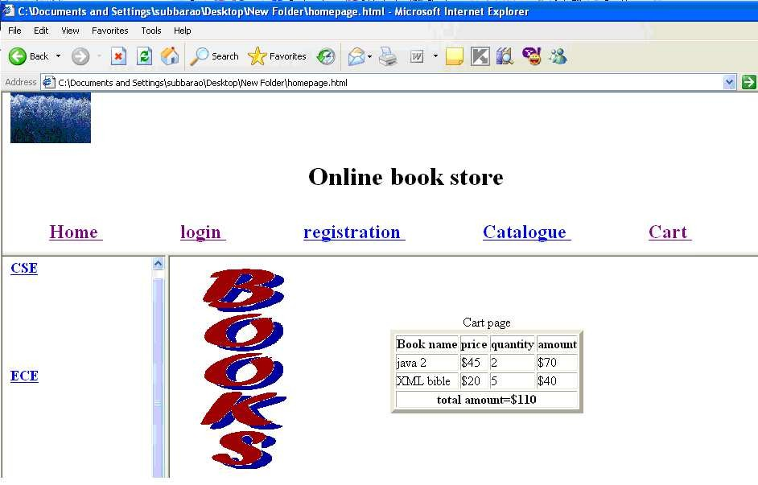

1. **REGISTRATION PAGE**

**DESCRIPTION:**

Create a “*registration form* “with the following fields 1) Name (Textfield)

1. Password (passwordfield)
2. E-mail id (textfield)
3. Phone number (textfield)
4. Sex (radiobutton)
5. Date of birth (3 selectboxes)
6. Languages known (check boxes – English, Telugu, Hindi,Tamil)
7. Address (textarea)

**PROGRAM:**

<html>

<body>

<center>

<imgsrc=”E:\aaa.jpg” align=”left”>

<form>

<label>name</label>

<input type="text" size="20"><br><br><br>

<label>password</label>

<input type="password" size="20" maxsize="28"><br><br><br>

<label>email</label>

<input type="text" size="30"><br><br><br>

<label>phone no</label>

<input type="text"size="2">

<input type="text"size="6">

<input type="text" size="10"><br><br><br>

<label>Sex</label>

<input type="radio" name="sex">m

<input type="radio" name="sex">f <br><br><br>

<label> date of birth</label>

<select>

<option>1</option>

<option>2</option>

<option>3</option>

<option>4</option>

<option>5</option>

</select>

<select>

<option>jan</option>

<option>feb</option>

<option>mar</option>

<option>apr</option></select>

<select>

<option>1980</option>

<option>1981</option>

<option>1982</option>

<option>1983</option>

</select><br><br><br>

<label> Languages Known </label>&nbsp; &nbsp;

<input type="checkbox"> English &nbsp;&nbsp;&nbsp;

<input type="checkbox"> Telugu &nbsp; &nbsp;&nbsp;

<input type="checkbox"> Hindi &nbsp; &nbsp; &nbsp;

<input type="checkbox"> Tamil <br><br><br>

<label> Address </label>

<textarea rows=5 cols=20 scrolling="yes"></textarea>

</center>

</body>

</html>

**OUTPUT:**

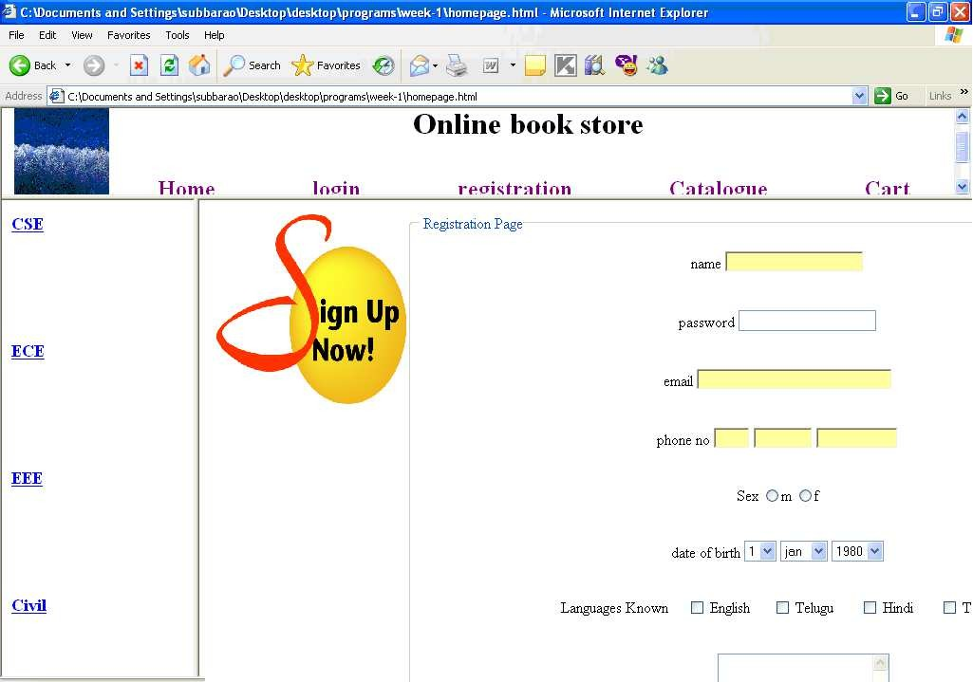

**RESULT:**

Thus the registration and cart pages for online book store pages are created successfully